connect people to nature

For over a decade, evidence has shown the importance of humans’ connection to nature for overall well-being and quality of life. Parks are being developed to enhance the natural environment, providing many mental, emotional, and physical health benefits. Nature based parks can help reduce anxiety and stress as well as offer discovery, problem solving, exploration, and social interactions for children. Below are ideas to enhance park users’ connection to nature. The Department of Conservation and Natural Resources (DCNR) also provides outdoor recreation, conservation, and stewardship resources. Learn more at DCNR’s Educational Resources page.

provide opportunities for interaction with nature
Provide a landscape to support a broad range of users and activities. This includes spaces for physical activity, nature/discovery trails, access paths to streams, way-finding features, and “cues to care”, which are design devices (such as mowed edges or low fences) that communicate a natural landscape that welcomes users.

identify local culture/community needs
The 2020-2024 Pennsylvania Statewide Comprehensive Outdoor Recreation Plan: Recreation for All, provides recommendations and actions for state and local agencies and recreation providers to get all the people of Pennsylvania into the outdoors and nature. In addition, this plan strives to provide new parks and green space in areas lacking for close to home recreation. Studies show that low income urban communities lack access to parks and open space and are impacted by climate change more than any other community. It is important to identify the needs of all potential users to ensure access to park and natural areas.

design spaces that address children’s needs
Design interesting spaces with natural elements that encourage exploratory and imaginative play. For example boulders for climbing, streams for discovery, open meadows with trails, sensory gardens (where children can touch, smell, and even taste plants), water features where children can manipulate sand and water, and large trees and other natural features for hide-and-seek and unstructured activities.

educate site users
Create demonstration gardens that allow visitors to observe biodiversity and learn how they can establish the same type of garden on their property. Protect wetlands and other natural areas and provide interpretive materials to educate about the benefits provided by these features. Facilitate wildlife viewing and learning by establishing bird boxes, observation areas/structures and stationary viewers with educational exhibits about the types of wildlife visitors might see. Provide interpretive materials or stations that inform about local ecosystems and their functions. Incorporate signs along an interpretive trail through a native wildflower and grass meadow that explains how these habitats are beneficial for humans and wildlife. Consider planning events and activities that bring the public to your parks and open spaces and provide the opportunity to learn and connect with nature.

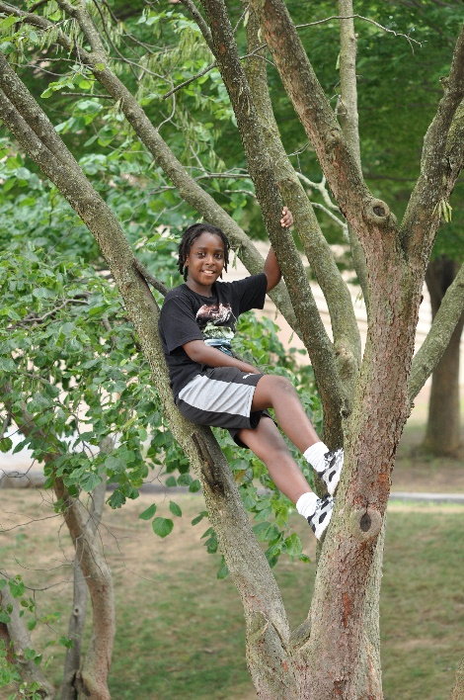
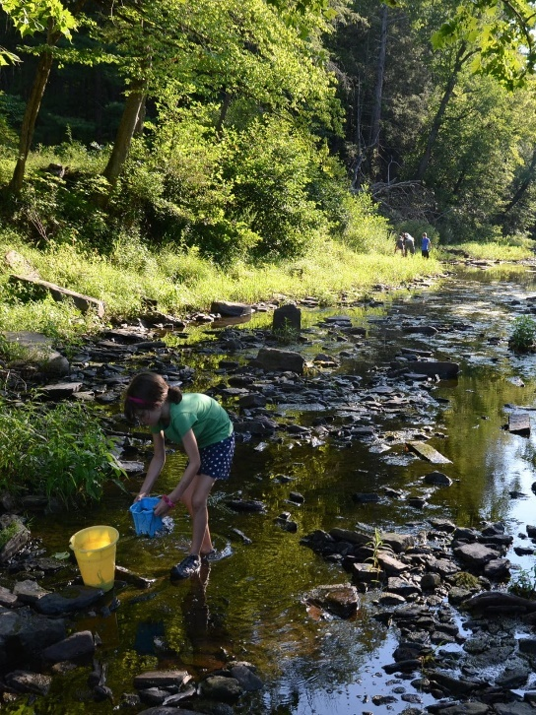

relaxed rules and simple designs
Child-centered, unstructured play allows children the freedom to interact with, change or observe the outdoor space without adult rules. By relaxing the rules allows discovery to flow naturally. Children need outdoor spaces that allow them to catch tiny critters, collect leaves and rocks, roll down a hill, explore a tall grassy area, splash in a creek, jump in puddles, dig in the sand or soil, hide among the shrubs or climb in a tree. These spaces do not have to be sophisticated; they just need to contain elements of nature that children will play with, explore, and love. Through this, they may develop a lifelong love and appreciation for the environment, leading them to become future stewards of the natural world.

plant trees
Trees provide a variety of benefits to people all the while contributing to a community’s climate resiliency by improving water quality, reducing erosion, and infiltrating stormwater. In the past, trees were not always recommended in park spaces because of the maintenance; however, people are looking for natural spaces to enjoy and trees provide all of the qualities for that experience. Studies have shown connecting with nature through a slow walk in the woods, even for a short period, has a positive wellness impact, like reducing blood pressure, lowering stress hormones, improving concentration and memory, and lifting depression. Trees supply shade along trails, sports fields, and playgrounds, creating a more enjoyable outdoor experience.

support on site food production
By turning vacant parcels into viable garden space, opportunities for on-site food production increases. These urban agricultural practices can improve the environment, revitalize neighborhoods, and have direct benefits to residents’ food access and nutrition. Other options for urban gardens include windowsills and balconies, public parks, vacant lots, and even roofs.
Kids who garden are more likely to eat more vegetables and the combination of the social aspect of gardening, along with the increased access to fresh fruits and vegetables, creates healthier overall lifestyles.

more resources:

- WeConservePA – Nature Play
https://conservationtools.org/guides/135-nature-play

- Nature Explore. https://natureexplore.org/

- Recreation Management. Nature and Nurture, Trends in Play Design. http://www.recmanagement.com/feature_print.php?fid=200907fe02

- DCNR Education Resources
https://www.dcnr.pa.gov/Education/Pages/default.aspx

- National Wildlife Federation. Connecting Kids and Nature. https://www.nwf.org/Kids-and-Family/Connecting-Kids-and-Nature

- Children & Nature Network. http://www.childrenandnature.org/movement/naturalfamilies/clubs

- EPA. Brownfields and Urban Agriculture. https://www.epa.gov/sites/production/files/2015-09/documents/bf_urban_ag.pdf

- Pennsylvania Statewide Comprehensive Outdoor Recreation Plan. https://www.dcnr.pa.gov/Recreation/PAOutdoorRecPlan/Documents/PASCORP2020-2024.pdf

- Nature Play Parks - Funding Resource
https://www.amwater.com/corp/customers-and-communities/american-water-charitable-foundation/signature-program

